BLOGPOST - 4 Key Insights from Analyzing 5,000+ Cap Tables

4 Key Insights from Analyzing 5,000+ Cap Tables
Capshare recently published the 2016 Private Company Equity Statistics Report. In it, we analyzed a significant subset of the 5,000+ cap tables on our system.
We identified 4 big insights in our research:
- Average dilution by stage is highly predictable
- Founders often own far less at exit than they might think
- Star performers and average performers have wildly different experiences
- Later rounds don’t always translate to increased returns for founders
We’ll explore these insights in the post below. If you want to see get the full report with a broader set of insights–download it here.
But first, an analogy from the world of artificial intelligence…

How Learning from Equity Benchmarks Can Inform Your Decisions
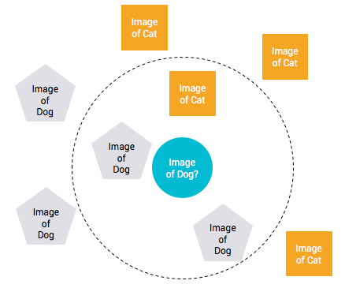

I recently read Pedro Domingos’ great book on machine learning, The Master Algorithm. In it, Pedro describes what may be one of the most efficient learning algorithms ever.
Let’s say you are trying to write some code to identify digital pictures containing a dog. It turns out it is nearly impossible to write a decision tree program that can accurately identify a dog. Every rule you could imagine (four legs, elongated snout, tail) has an exception or is shared by another animal.
Often the best coders are lazy. So they figured out a lazy approach to solving the problem. They identified the most similar pictures in their database and compared the target picture with them.
If the most similar pictures contained a dog, then they assumed that the target picture must also contain a dog. This became what is called the k-nearest neighbors algorithm for learning by analogy.
So what does this story about machine learning have to do with cap tables and startups?
Our goal in putting together the Capshare Private Company Equity Statistics Report was to provide statistical data to help startup executives find analogies, patterns, and similarities in related startups.
With this data and future data we will release, you should start to identify the nearest companies to your own and learn by analogy.
Insight #1: Average Dilution By Stage Is Highly Predictable
Few would argue that creating equity value is one of the most important reasons for starting a company. By definition, founders start out with 100% ownership. But it only goes down from there. This concept is called equity dilution.
Companies often care about the effects of dilution on different groups: all shareholders, all employees (as opposed to investors), and founders. How quickly equity dilution occurs and by how much is the biggest determinant of the ultimate equity value of a typical shareholder (including founders).
Fred Wilson, the famous venture capitalist, said in a 2009 article that founder dilution “…is a subject near and dear to entrepreneurs, maybe the dearest subject of them all.”
In the same article, Fred lays out the following averages:
Founders who “go all the way” through the process of building a lasting and sustainable/profitable business (as opposed to an early exit) will generally suffer the most dilution. In my experience, it will generally take three to four rounds of equity capital to finance the business and 20-25% of the company to recruit and retain a management team. That will typically leave the founder/founder team with 10-20% of the business when it’s all said and done. The equity split at 20% for the founders will typically be; 20-25% for the management team, 20% for the founders, and 55-60% for the investors (angel all the way to late stage VC).
Fred and others have pointed out significant limitations with these rules of thumb. The biggest limitation is that founder dilution changes dramatically based on the stage of a company at exit.
Some companies may sell at the Series Seed stage and others may exit after a Series F. Another way to say this is that it isn’t clear what it will take to “go all the way.”
Based on our analysis, Fred’s estimates were really accurate from companies at or beyond the Series D stage. But we also collected data for all of the earlier stages.
To gather the data, we made a simplifying assumption. We assumed that founders owned 100% of common stock and restricted stock on the cap tables we analyzed. Based on this, we found the following dilution curve:
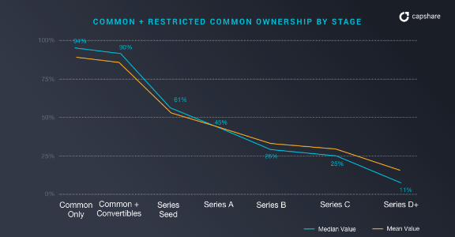

We also looked at total non-preferred ownership. This would include founder and non-founder equity. If you subtract these numbers from 100%, you will get a great estimate of all investor ownership.
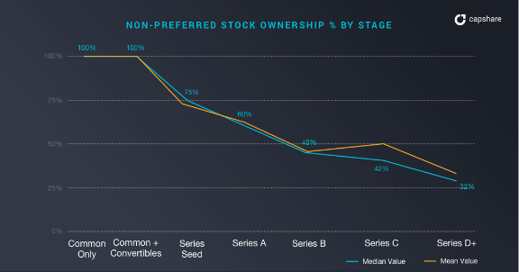

So if your company exits around Series D, you can expect the following splits:
- Founder ownership: 11-17%
- Other employees: 17-21%
- Investors: 66-68%
Those numbers are really consistent with Fred’s estimates.
Founders and employees can end up owning a lot more but only if they sell before the Series D.
It turns out that we can fit a line almost perfectly to these graphs.
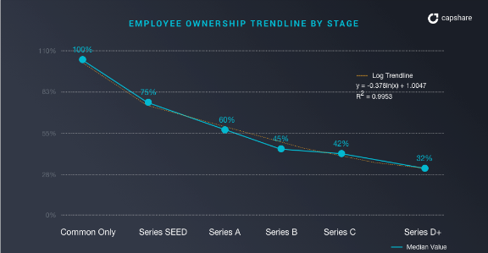

Based on this data, we identified what we call the Employee Ownership Formula:
Y = -0.378 * ln(X) + 1
where Y is the fully-diluted employee + founder ownership on the cap table, and
X is the number of series of fundraising rounds your company has
You can use this formula to predict the average total employee ownership of any startup or benchmark your own. So if you have raised two rounds, your employee ownership should be around 73%.
Insight #2: Founders Often Own Far Less At Exit Than They Might Think
A lot of founders start out thinking that they will own 40%-50% of their company when they sell. In reality, they will likely own far less.
Part of this reality is rooted in the fact startups take a long time to exit. The NVCA created a weighted average exit analysis that weights the number of IPOs and M&A exits for typical venture-backed companies. The graph below charts the weighted average time to exit for startups that exited in each year.
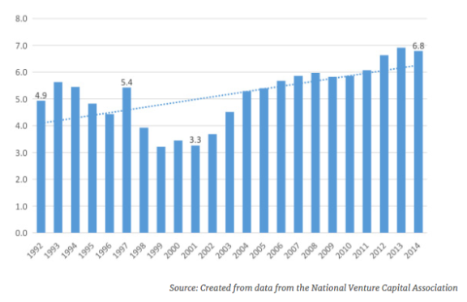

The average as of 2014 was approximately 7 years, and the trendline suggests that exit timeframes are getting longer.
If we assume a typical company raises 4-5 rounds over that timeframe, employees (including founders) would own 40-47.6%.
Using assumptions from the previous section about splits between founders and other employees, founders should expect to own 16-21% of their company at exit.
So if there are 3 founders, an individual founder may only own 5-7% of the company at exit. That’s quite a bit less than most expect.
Insight #3: Star Performers and Average Performers Have Wildly Different Experiences
In the graphs above, the mean and median numbers don’t always line up. Typically the mean employee ownership is higher than the median ownership at later stages.
This indicates that there are some outlier companies where the employees own more than most of the other companies. This raises the mean (or average) up.
The distribution graph below shows this effect dramatically. We found a group of “typical” or “median” companies and a group of “outlier” or “star” companies.
For example, when we looked at valuation data at any stage, we found distributions that looked like this.
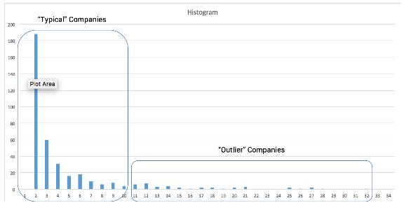

This implies that while most companies have moderate valuations, there is a very long tail of companies with significantly higher valuations.
The difference in pre-money valuations between the “standard” and “star groups” at Series D is an astounding $144M. The gap begins at the Series Seed and persists at all stages.
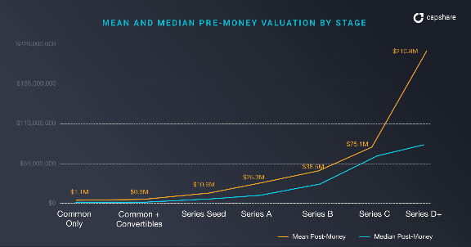

This data confirms a commonly held belief — a relatively small percentage of companies command the highest valuations. Most companies receive significantly lower valuations than the top performers.
Receiving a billion dollar valuation is an extremely rare event for a start-up — it’s why they’re called “unicorns” after all.
These top-performing companies have a much stronger waterfall outlook for employees.


Waterfall analysis, is the calculation of the payouts to all security classes and shareholders from zero to infinity taking into account the following factors:
- Liquidation preferences
- Participation rights and caps
- Conversion rights
- Cumulative dividends
- PIK dividends
- Options and warrants
Based on this analysis, you can calculate payouts to all shareholders at any hypothetical exit value for the company.

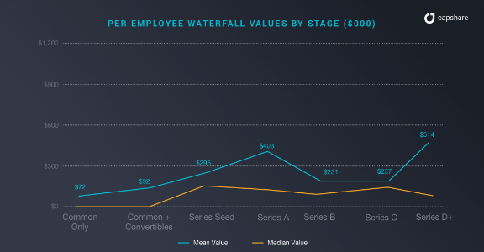

To get this waterfall data, we calculated the average payout per employee if the company sold for its most recent post-money valuation.
Median per-employee waterfall values hover around $130-$190K. Mean per-employee waterfall values are about 2-5x that value.
Remember, per-employee figures include founder amounts. So non-founder employee numbers could be significantly smaller. A fair assumption is that non-founder employees values would be roughly 50% of the figures above.
What does this mean in practice? If you are a mid-level employee at a relatively unknown (but somewhat successful) startup, your equity is probably worth $65-95K if the company exits at its latest valuation.
By contrast, if you are a mid-level employee at a company like AirBnb, your equity could be worth somewhere around $130K-$500K.
Insight #4: Later Rounds Don’t Always Translate to Increased Returns for Founders
A former Harvard Business School professor recently released research into the effect of founder control on startup valuations.
He found that valuations of founder-controlled companies are 17% – 44% lower than non-founder-controlled companies.
This would seem to indicate that giving up control is a key to creating more value.
This could be simple correlation rather than causation.
Our research shows that founders generally can’t retain control of their company beyond the Series A round. The graph below shows founders typically own only 45% of a Series A company.

If it is simple correlation, it is fairly obvious why non-founder-controlled companies are worth less: They simply haven’t been able to raise a round past Series A.
Regardless, founders should care more about their personal returns than the overall valuation of the company.
Valuation is just one of three key factors that influences personal returns for founders. The other two being ownership percentage and liquidation preferences.
Our research shows that founder returns are really high if you are in a star company but quite a bit lower than what you might expect if you are in a “median” company.
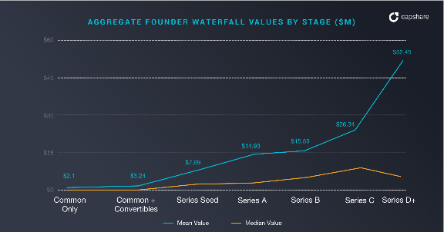

In our analysis, the founders’ stock (as a group) was worth only $6.52M at a “median” as opposed to $52.45M at the mean company.
If you have 2-3 founders, the per-founder returns could be much smaller. In other words, at Series D+ stages, the founders are filthy rich at “star” companies but only just cracking the million dollar mark in the more typical startup.
Also, notice the growth in value for the mean line versus the median line. This implies that raising additional rounds of funding is probably a no-brainer if you are in the “star” group. The economic rewards are enormous.
Along with many well-documented positives, raising venture capital brings several potential negatives including:
- Increased liquidation preferences
- Increased pressure to grow
- Focus on growth over profitability (increased risk)
- Giving up control
- Cultural changes
We’ve discussed this further in our articles on Saas myths and term sheets.
If your company is more of a “median” company, it often makes economic sense to keep raising venture capital, but not always. The economic rewards of raising more and more venture capital are muted.
Our research indicates you should make sure that the extra $500K-$1M in waterfall value you get is worth what you give up.
We hope you enjoyed our top 4 key insights from the most recent Capshare Private Company Equity Statistics Report.
Download the entire report to get access to the following additional information:
- More details about dilution
- Dilution percentages based on financing rounds
- Pre- and post-money valuation data by stage
- Information about the prevalence of various security types by stage
- More comprehensive waterfall analysis
- And quite a bit more
Manage All Your Equity in 1 Place
Manage your cap table, issue shares, analyze funding rounds, and automate all your equity without getting bogged down in spreadsheets and paperwork
Sign Up Free

Aus <https://www.capshare.com/blog/4-key-insights-from-5000-cap-tables/>

